Day in the Life of the Hudson River 10/14/21
Long Dock, Beacon
RIVER MILE: 61
Salt Front: ~ RM 49
Kate Phipps & Scenic Hudson Staff- 4 adults
no students at this site
Latitude 41.50312 N & Longitude – 73.98696 W
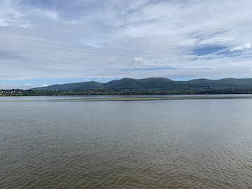
Looking across to Newburgh – Calm waters with mat of plant material dotted with birds offshore

Location: Long Dock Park, Beacon, Dutchess County, NY
Area: Long Dock Park- a former brownfield now public park used for fishing, launching kayaks, picnics, fieldtrips, enjoying scenic view of the Hudson River, Hudson Highlands, and Hudson Valley. Most of the shoreline on the south side is lined with trees.
Surrounding Land Use: 25% Forested; 15% Beach; 60% Other
Sampling Site: Beach area rocky with lots of sand, water chestnut and grass
Plants in area: water chestnut
River Bottom: Muddy, Rocky

*NR = Not Recorded NA= Not Apply
ITEM | Time | Reading |  |  | Comments
Physical
Air Temperature | 1:50 PM | 24 º C | 75.2 º F
Wind Speed: | NR
Weather today | 1:50 PM | <25% cloud cover | No rain
Weather the past 3 days: | Cloudy, seasonably warm, some drizzle
Tides- | Time | Cm/sec | Knots |  | North/South Ebb/Flow
 | NR | NR | NR |  | N/A
Water Temperature- collected from bucket | 1:50 PM | 21 º C | 69.8 º F
Turbidity- Long sight tube | 2:00 PM | 86 cm
Chemical
Salinity- Low Range Quantab | 1:55 PM | Quantab reading 1.4 | 32 ppm chloride |  | 58 ppm Total Salinity
Standardized Salinity –  Low Range Quantab | 2:15 PM | Quantab reading 2 | 51 ppm chloride |  | 92 ppm Total Salinity
DO – Hatch Drop Count kit | Time | Temp | ppm DO |  | % saturation
 | 1:50 PM | 21 º C | 11 ppm |  | 120%
pH – color match | 1:55 PM | 7.1
Biological
Fish – | Number | Name | Length of longest |  | Length of smallest
NA did not seine
Fish Totals | TOTAL: | Diversity:
Macroinvertebrates | Number | Name | Length of longest |  | Length of smallest
NA did not sample
Macroinvertebrate Totals | TOTAL: | Diversity:

